12th BILL HOSKYNS OPEN
is moving to APRIL!
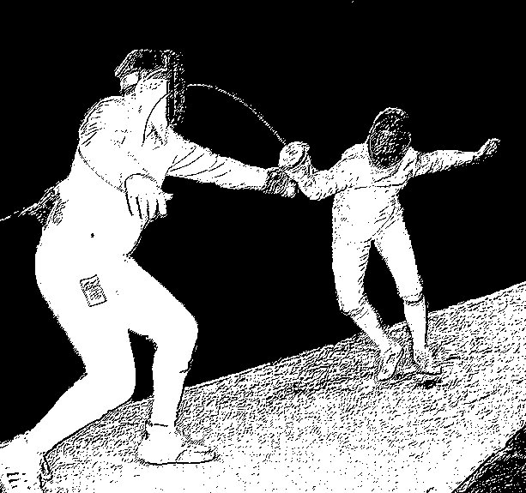 | Saturday 23rd April 2016  Men’s Epee  Sunday 24th April 2016  Women’s Epee  Also on Sunday 24th  Men’s Team Epee  Boys’ under 13 Epee  Girls’ under 13 Epee
It’s the same event, run in the same way, in the same venue, just at a different time of year

Pistes We will have 18 metallic pistes. The whole competition will be fought on metal.

Venue Wyre Forest Glades Leisure Centre, Bromsgrove St, Kidderminster, Worcestershire,
DY10 1PP (directions are available on request).

Format Senior event will be fenced as two rounds of pools with elimination and repechage. Depending on numbers the men’s event may have a cut after each round of the pools.
Under 13 events will be one round of pools and DE. Teams will be relay.

Prizes Senior events will have a trophy for first place, medals for first to third, t-shirts for the top eight. Under 13 events will have a trophy for first and medals for first to third.
There is also a medal for top cadet in the senior event.

Closing date Saturday 16th April 2016.
Entry Limit Please note entries are limited to 126 in the Men’s, 84 in the Women’s and 12 teams.
Check in Check in will close at 9.00 am for the seniors, 9.30 for the teams, 10.30 for the under 13’s.
Entry Fee £27 seniors, £15 under 13’s, £36 teams. Please make cheques payable to;
‘Fencing Camps and Comps’. Late entries +£10.
Age All participants must be over 13 for the open and under 13 on 1st January 2016 (ie born in 2003 or later) for the under 13’s!
Equipment Fencers must wear full safe correct kit.
BFA Membership of a National Fencing Association is compulsory.
Refreshments The leisure centre has a cafe.
Parking I regret to say parking in Kidderminster is all pay and display.

Further information Call Nick Chapman on 07980 757502
Or email on nick.chapmancoach@gmail.com
12th BILL HOSKYNS OPEN
2016 Entry Form

Individuals
Name _____________________________________________
Address _____________________________________________
_____________________________________________
Telephone No _____________________________________________
Email Address _____________________________________________
Please tick this box if you do not want your email address to be retained and used for circulating information about other relevant events (i.e. this event next year) □
Club _____________________________________________
If under 18’s state your ‘Date of Birth’_____________
National Fencing Association membership number _____________________________
(All participants are expected to be members. Membership applications will be accepted on the day)

Number to be contacted in case of an emergency___________________________
- Please detail any relevant medical information on the back of this form

Please delete as applicable;
Men’s Epee Saturday 23rd April 2016 (£27 per person)
Women’s Epee Sunday 24th April 2016 (£27 per person)
Boys’ under 13 Epee Sunday 24th April 2016 (£15 per person)
Girls’ under 13 Epee Sunday 24th April 2016 (£15 per person)

Men’s Team's (£36 per team) Team name ____________________________

Fencer 1 __________________________ Membership no.________ Signature_________
Fencer 2 __________________________ Membership no.________ Signature_________
Fencer 3 __________________________ Membership no.________ Signature_________
Reserve __________________________ Membership no.________ Signature_________
Contact number___________________________ Contact email__________________________________

All cheques are payable to ‘Fencing Camps and Comps’.

Each Fencer is personally responsible for making sure that his or her clothing and equipment conform to the FIE and British Fencing rules and are in good condition. Neither British Fencing, nor the organisers of the competition, nor any official or referee involved in the competition is responsible for these matters, or for any accident, loss or damage to persons or property however caused.

Signature ___________________________ (Parent or Guardian if fencer is under 18)
Date ____________
Please return entries with appropriate fee to Nick Chapman
5 Nine Days Lane, Wire Hill, Redditch, Worcs, B98 7TE
For further information call Nick on 07980 757502 or nick.chapmancoach@gmail.com

